Razeen M.R.M

IT24300057

PS – Lab 10

State the null and alternative hypotheses for the test. 3

Null Hypothesis ($H_0$): The customers' choice of snack type follows a uniform distribution. That is, the probability of choosing snack A, B, C, or D is equal ($P_A = P_B = P_C = P_D = 0.25$).

Alternative Hypothesis ($H_a$): At least one snack type has a selection probability that is not 0.25. The customers' choice of snack type does not follow a uniform distribution.

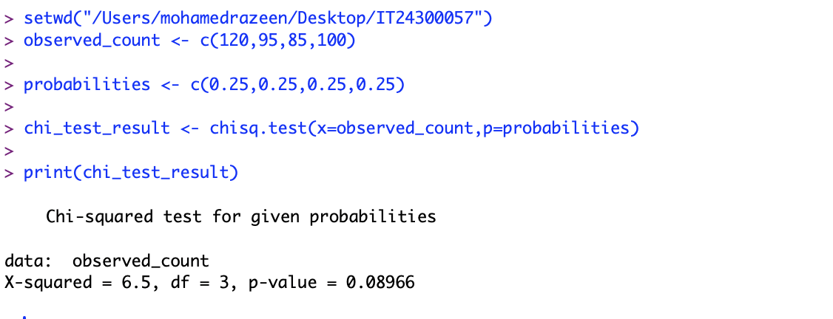

P-value: The p-value from the test is approximately 0.0897.

Decision: Since the p-value (0.0897) is greater than the significance level (0.05), we do not reject the null hypothesis.

Conclusion: we do not reject the vending machine owner’s claim.